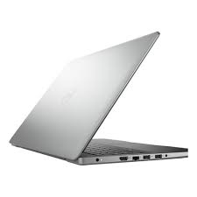

Dell Inspiron 3501

* Intel Core I3-1005G1
* 4M Cache,To 3.40 GHz
* 4GB Memory, 1TB HDD
* 15.6-Inch FHD
* **Rs.97,500**